POST request

localhost:3000/api/user

<https://www.prisma.io/docs/orm/overview/prisma-in-your-stack/rest>

**REST API server example**

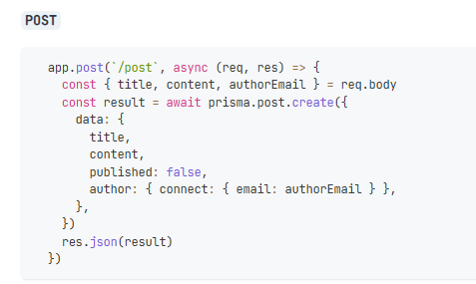

Add new POST request to the http request and server.js as below



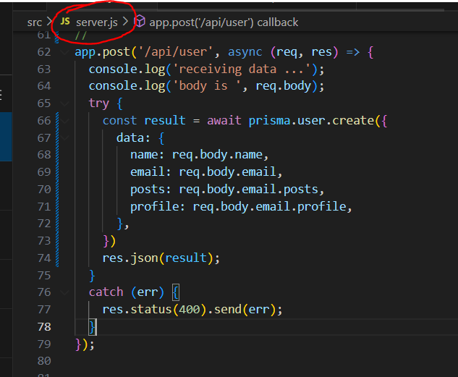

Server.js

app.post('/api/user', async (req, res) => {

  console.log('receiving data ...');

  console.log('body is ', req.body);

  try {

    const result = await prisma.user.create({

      data: {

        name: req.body.name,

        email: req.body.email,

        posts: req.body.email.posts,

        profile: req.body.email.profile,

      },

    })

    res.json(result);

  }

RUN server… | npm run dev

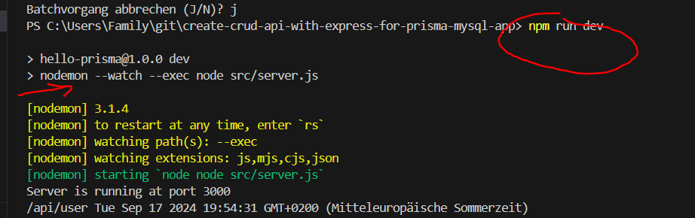

Assign Body data to the new POST request as below:

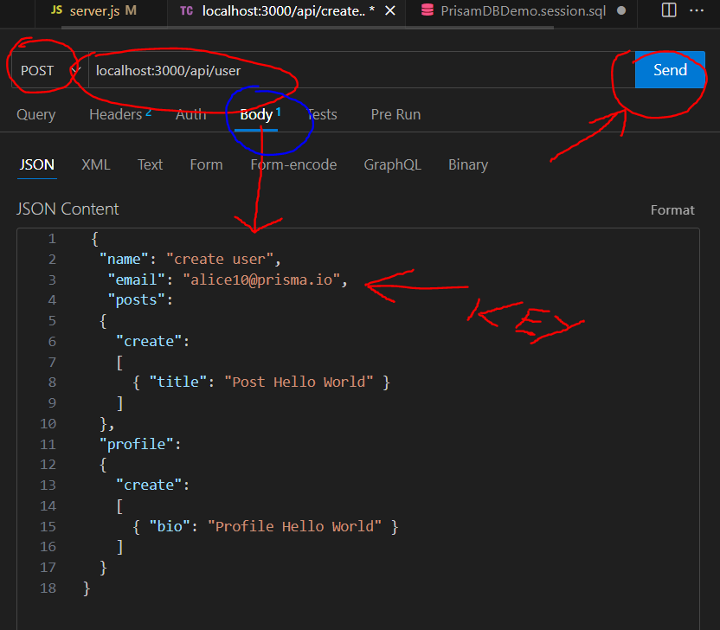

Body - JSON Content   
  
{

"name": "create user",

"email": "alice10@prisma.io",

"posts":

{

"create":

[

{ "title": "Post Hello World" }

]

},

"profile":

{

"create":

[

{ "bio": "Profile Hello World" }

]

}

}

Click 🡪 Send button 🡪 Response 🡪 Status 200 OK 😊

GET Response Result 🡪 OK

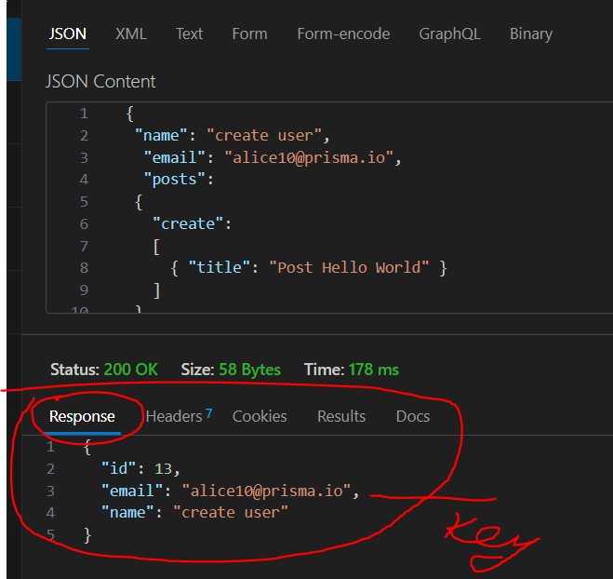

* Check MySQL database

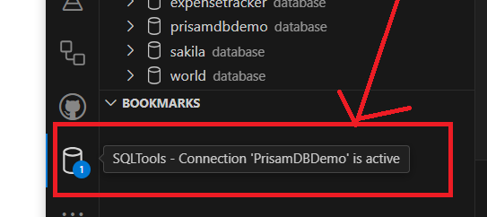

Request data was inserted into database OK 😊

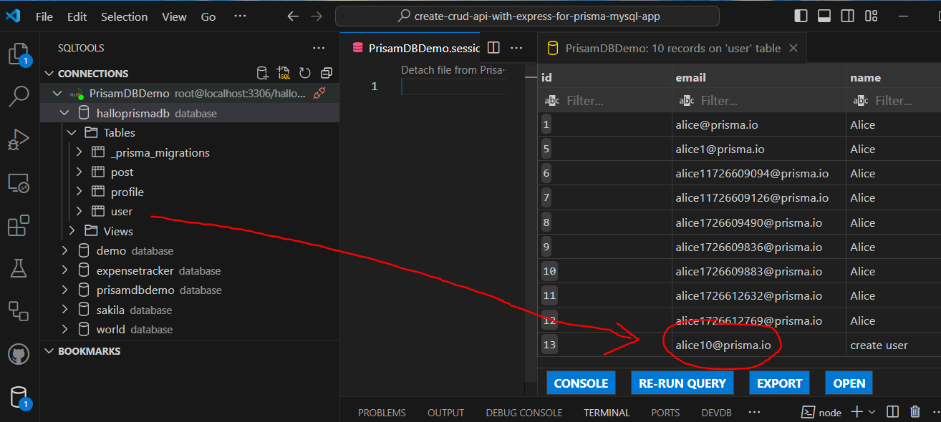

LOG http Request Body data OK 😊

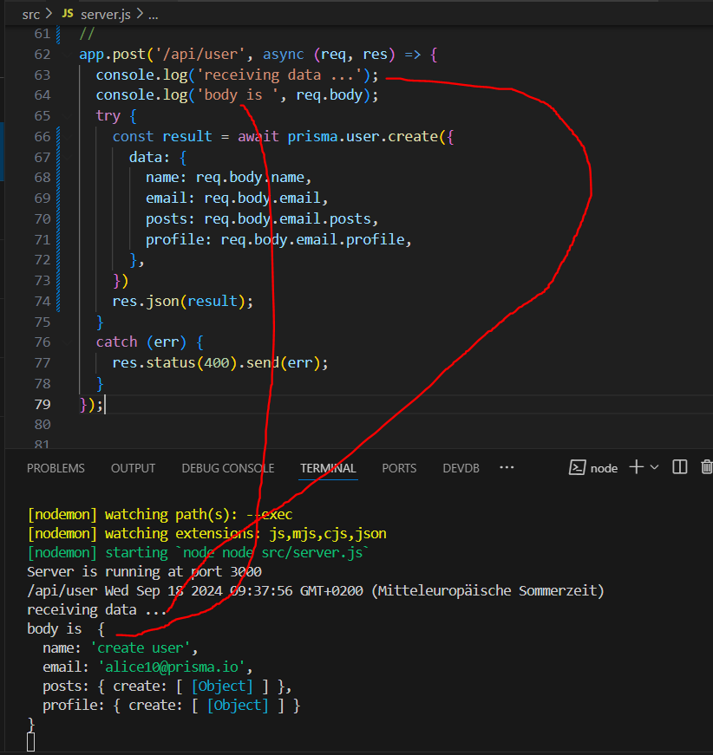

POST Request OK 😊